Software Project Management
PBL

Submitted by:
Ahmad Zia
M. Abdullah
SAP ID: 54635
47618
BSSE 6

Project Title:
Tourguide
.

Lab:1

1. Formation of Project Groups

1.1 Group Details
Field | Details
Member 1 Name | Ahmad Zia
Member 1 Roll No. | 54635
Member 1 Role | Team Leader & Full Stack Developer
Member 2 Name | Abdullah
Member 2 Roll No. | 47618
Member 2 Role | Documentation Coordinator

1.2 Role Descriptions

Team Leader & Full Stack Developer (Ahmad Zia)
Responsible for project planning, task allocation, frontend and backend development, database integration, and ensuring timely completion of project deliverables.

Documentation Coordinator (Abdullah)
Responsible for preparing project reports, maintaining documentation, updating project records, and assisting in requirement analysis.

2. Selection of Software Project

2.1 Project Title

Tour Guide Application – Web Based Tour Booking System

2.2 Project Overview
Tour Guide Application is a web-based platform developed to simplify tour package booking and management. The system consists of two user roles: Customers and Administrators.
Customers can create accounts, login securely, browse tour packages, book trips, manage carts, upload travel photos, submit ratings, and send queries to administrators.
Administrators can manage tour packages, monitor customer activities, review submitted queries, and mark resolved issues through an administrative dashboard.
The application provides a centralized and user-friendly environment for travelers and tourism companies.

2.3 Project Objectives
• Provide an online platform for browsing tour packages.
• Allow customers to register and login securely.
• Enable customers to book tours and manage carts.
• Provide package pricing calculations.
• Allow customers to upload travel images.
• Enable customers to submit ratings.
• Facilitate customer query submission.
• Provide an admin dashboard.
• Allow administrators to perform CRUD operations on packages.
• Enable administrators to manage customer queries.

3. Identification of Stakeholders

3.1 Stakeholder Categories
Stakeholder Category | Role | Interest Level
Tourism Company | Client | High
Customers | End Users | High
Project Manager | Supervision | High
Developers | System Development | Medium
Testers | Quality Assurance | Medium
Administrator | System Management | High
Hosting Provider | Infrastructure | Medium

3.2 Stakeholder Interest Description

Primary Stakeholders
Customers are the primary users of the system. Their satisfaction directly determines project success.
The Tourism Company acts as the client and defines business requirements.

Secondary Stakeholders
Developers implement the software features.
Testers validate application quality.
Project Manager oversees project progress.

External Stakeholders
Hosting providers ensure application availability and deployment support.

4. Problem Statement Definition

4.1 Current Issues
• Customers depend on phone calls or physical visits to book tour packages.
• Traditional booking methods are slow and inconvenient.
• Customers cannot easily compare available packages.
• Feedback collection is mostly manual.
• Customer queries are not centrally managed.
• Package information updates require significant manual effort.

4.2 Limitations of Manual Processes
• Booking procedures consume considerable time.
• Manual record keeping increases chances of errors.
• Customer feedback and travel galleries cannot be efficiently maintained.
• Administrators face difficulties in managing package information.

4.3 Expected Improvements Through Automation
• Customers can browse and book packages anytime.
• Cart functionality provides transparent pricing.
• Travel photos and ratings enhance customer engagement.
• Query submission improves communication.
• Admin dashboard simplifies package management.
• CRUD operations reduce administrative workload.
• Centralized data storage improves system efficiency.

4.4 Problem Statement Summary
Travelers often experience difficulties in finding suitable tour packages, booking tours, sharing travel experiences, and communicating with tourism companies. Existing manual processes are time-consuming, inefficient, and lack centralized management.
The Tour Guide Application addresses these issues by providing a web-based platform that enables customers to browse packages, manage bookings, upload images, submit ratings, and communicate through queries. Administrators can efficiently manage packages and customer interactions through a dedicated dashboard, resulting in improved customer satisfaction and operational efficiency.

Lab:2

1. Gantt Chart in MS Excel

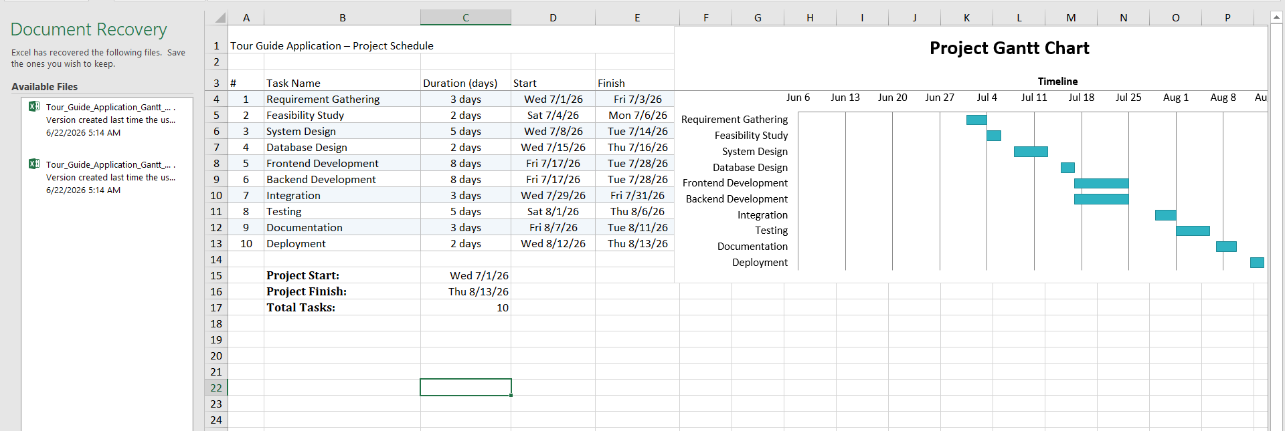

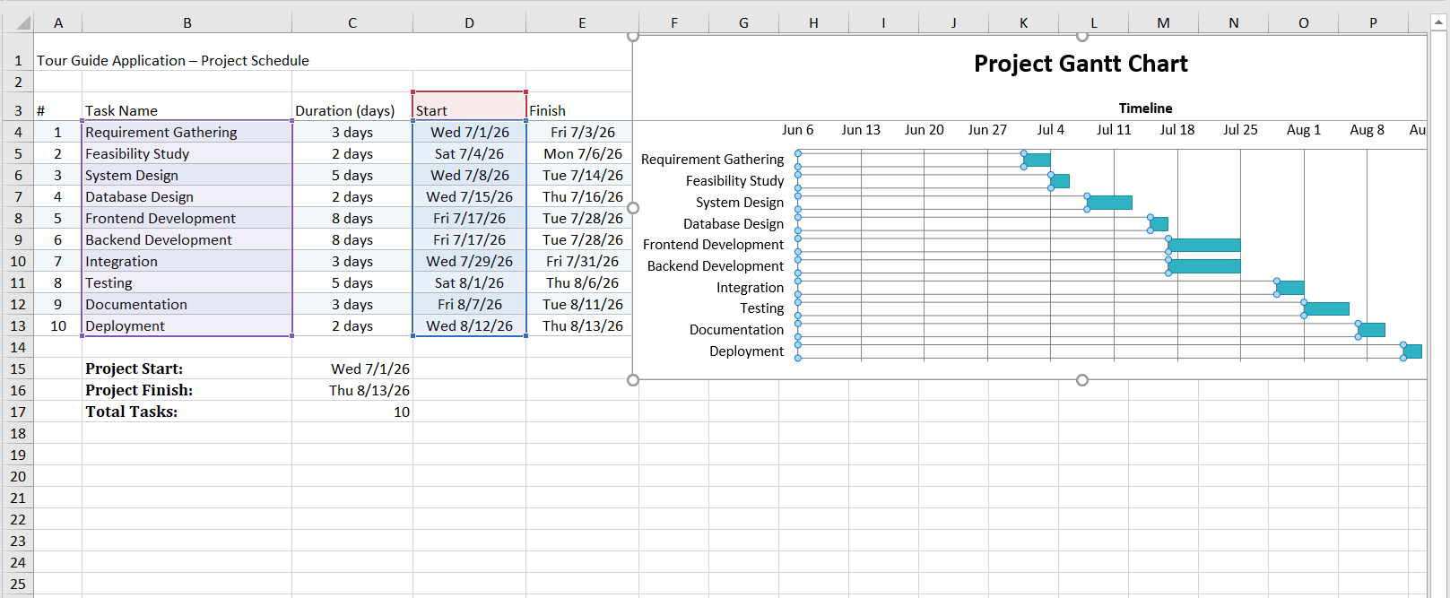

Lab 3:

1. Project Description

Problem Statement
Tourists often face difficulties in finding suitable tour packages, booking tours, sharing experiences, and communicating with tour operators. Traditional booking methods are time-consuming and inefficient. A centralized system is needed to simplify package browsing, booking, feedback, and customer support.

Project Objectives
- Provide an online platform for tour package booking.
- Allow customers to browse and book tour packages.
- Enable customers to manage their cart and view total costs.
- Allow customers to upload travel images and ratings.
- Facilitate customer query submission.
- Provide an admin panel for package and query management.

Brief System Overview
The Tour Guide Application is a web-based system consisting of two user roles: Admin and Customer. Customers can register, login, browse packages, book tours, manage carts, upload gallery images, submit ratings, and send queries. Admins can manage tour packages, handle customer queries, and monitor system activities.

Stakeholders
Stakeholder | Role
Client | Tourism Company
Customers | End Users
Project Manager | Project Supervision
Developers | System Development
Tester | Quality Assurance
Admin | System Management

2. Feasibility Analysis

Technical Feasibility

Required Technologies
- React.js
- Node.js
- Express.js
- MongoDB
- HTML
- CSS
- JavaScript

Tools/Platforms
- Visual Studio Code
- MongoDB Atlas
- GitHub
- Postman

Conclusion
The required technologies are widely available and team members possess the necessary skills.

Economic Feasibility

Estimated Cost
Item | Cost (PKR)
Development Tools | 10,000
Hosting | 15,000
Domain | 5,000
Testing | 10,000
Miscellaneous | 10,000
Total | 50,000

Expected Benefits
- Faster booking process
- Increased customer satisfaction
- Reduced manual work
- Better package management

Operational Feasibility

User Acceptance
The system is easy to use and user-friendly.

Organizational Support
The tourism company supports digital transformation and online booking systems.

3. Resource Planning

Resource Allocation Table
Resource Type | Resource | Quantity
Human | Project Manager | 1
Human | Developers | 2
Human | Tester | 1
Human | Documentation Lead | 1
Hardware | Laptop | 5
Software | VS Code | 5
Software | MongoDB Atlas | 1
Financial | Budget | PKR 50,000

Resource Utilization Strategy
- Developers handle coding.
- Tester performs system testing.
- Documentation Lead prepares reports.
- Project Manager monitors progress.

4. Time Planning

Activity Table
Activity | Duration (Days) | Dependency
Requirement Gathering | 3 | None
Feasibility Study | 2 | Requirements
System Design | 5 | Feasibility
Database Design | 3 | Design
Frontend Development | 10 | Design
Backend Development | 10 | Database
Integration | 4 | Frontend & Backend
Testing | 5 | Integration
Documentation | 4 | Testing
Deployment | 2 | Documentation

Project Duration
48 Days

Gantt Chart (Simple)



5. Cost Planning

Cost Estimation Sheet
Resource | Cost (PKR)
Project Manager | 15,000
Developers | 20,000
Tester | 5,000
Documentation | 3,000
Hosting | 5,000
Domain | 2,000
Total Budget | 50,000

Cost-Benefit Analysis

Costs
- Development Cost = PKR 50,000

Benefits
- Automated booking system
- Improved customer service
- Better management efficiency

6. Team Planning

Team Structure

Project Manager
- Ahmad Zia

Developers
- Developer 1
- Developer 2

Tester
- Tester 1

Documentation Lead
- Documentation Lead 1

Responsibilities
Role | Responsibility
Project Manager | Planning & Monitoring
Developers | Coding
Tester | Testing
Documentation Lead | Reports & Documentation

7. Risk Planning

Risk Register
Risk | Probability | Impact | Mitigation
Requirement Changes | High | High | Regular Meetings
Schedule Delay | Medium | High | Buffer Time
Resource Unavailability | Medium | Medium | Backup Resources
Technical Issues | Medium | High | Technical Support
Database Failure | Low | High | Regular Backups

8. Monitoring & Control Planning

Monitoring Frequency
- Weekly

Performance Indicators
Indicator | Measurement
Schedule Progress | Task Completion %
Cost Usage | Budget Consumed
Defects | Number of Bugs
Productivity | Tasks Completed

Reporting Mechanism
- Weekly Status Reports
- Progress Meetings
- Project Dashboard Updates

9. Communication & Meeting Planning

Communication Methods
Method | Purpose
Meetings | Progress Discussion
Email | Formal Communication
WhatsApp | Quick Updates
Reports | Project Tracking

Meeting Plan
Meeting Type | Frequency | Participants | Agenda
Team Meeting | Weekly | Team Members | Progress Review
Client Meeting | Bi-Weekly | Client & PM | Requirement Updates
Risk Meeting | Monthly | PM & Team | Risk Review

10. Change Management Planning

Change Request Process
- Submit Change Request
- Analyze Impact
- Review by Project Manager
- Approve/Reject Change
- Implement Approved Change

Impact Analysis
Area | Impact
Scope | New Features
Schedule | Increased Time
Cost | Additional Budget

Approval Authority
Project Manager

Change Request Template
Field
Request ID
Date
Requested By
Description
Impact
Approval Status

11. RACI Matrix
Task | PM | Developer | Tester | Client
Requirement Gathering | A | C | I | R
System Design | A | R | I | C
Development | A | R | I | I
Testing | C | C | R | I
Deployment | A | R | C | I
Documentation | A | C | C | I
R = Responsible
A = Accountable
C = Consulted
I = Informed

12. Rollout Planning

Deployment Strategy
- Deploy on cloud hosting platform.
- Connect MongoDB Atlas database.
- Perform final testing before release.

Production Environment Readiness
- Server configured.
- Database connected.
- Security checks completed.

User Training Plan
- Provide user manual.
- Conduct demonstration session.
- Provide video tutorials.

Acceptance Criteria
- User registration works correctly.
- Login validation works.
- Package booking works.
- Cart management functions properly.
- Admin CRUD operations work.
- Query management works.
- System passes all test cases.

Lab 4:

1 .MS Project:

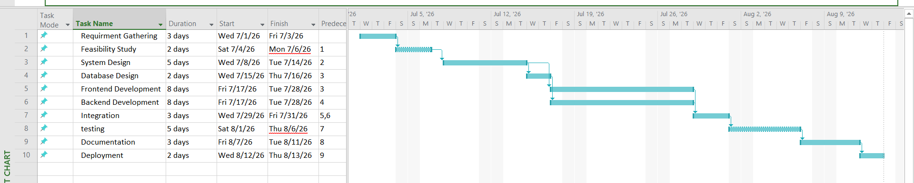

Lab 5:
1 .Project Planner:

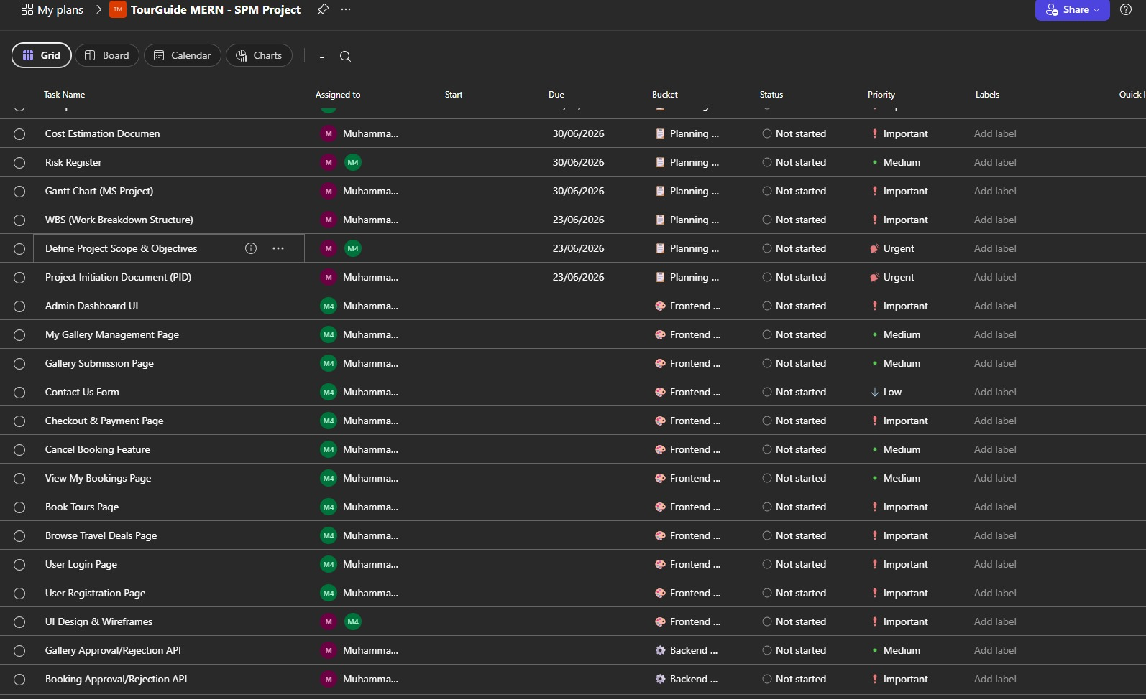

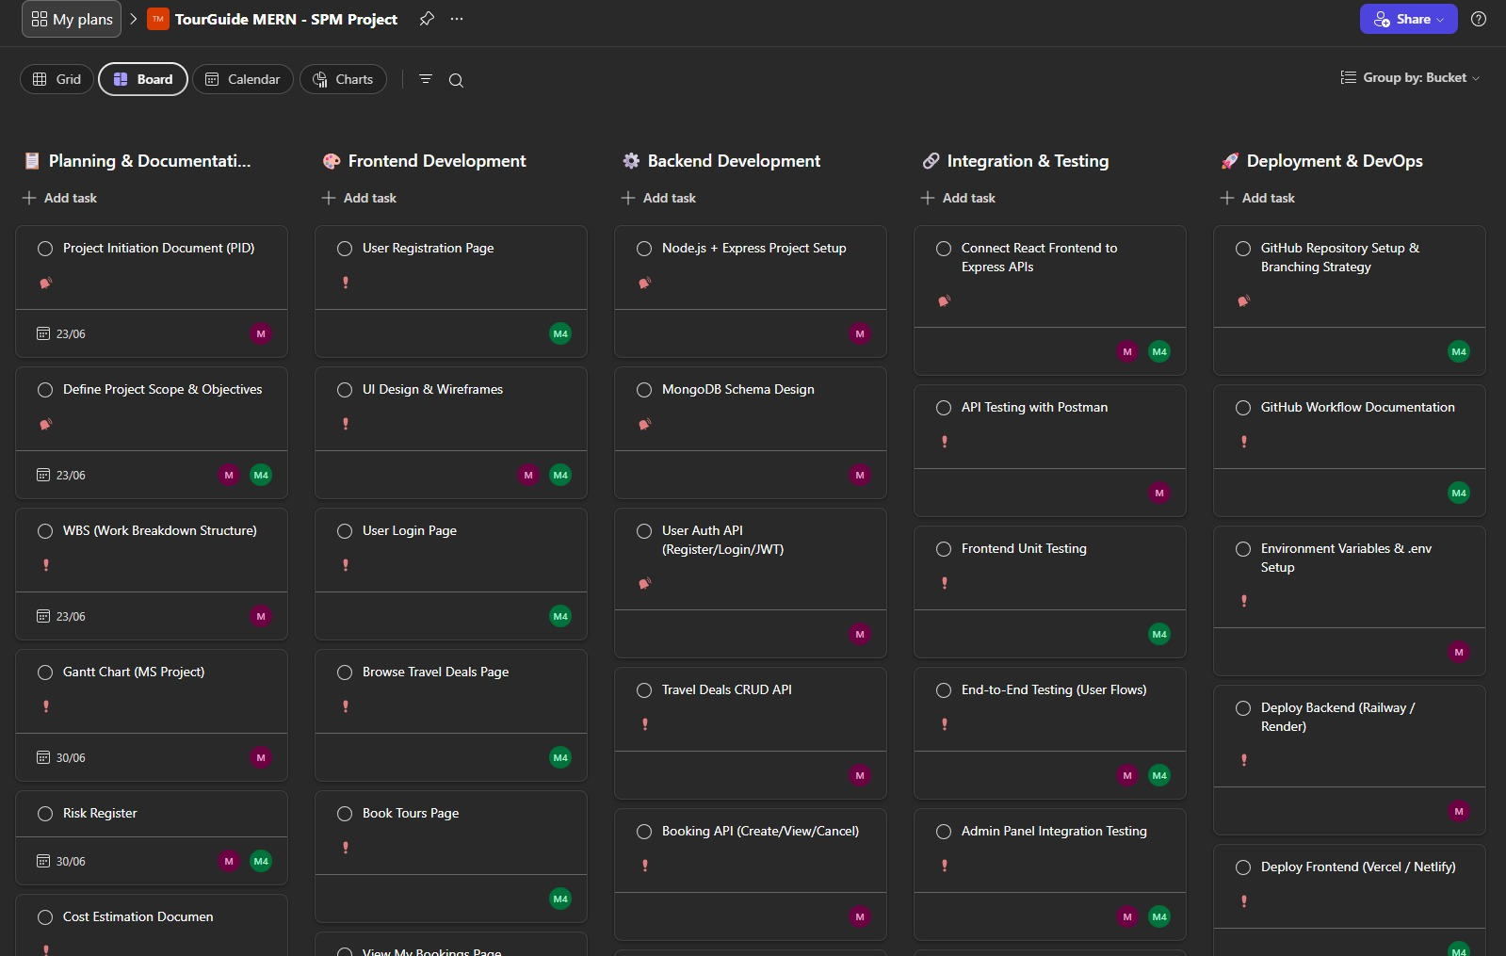
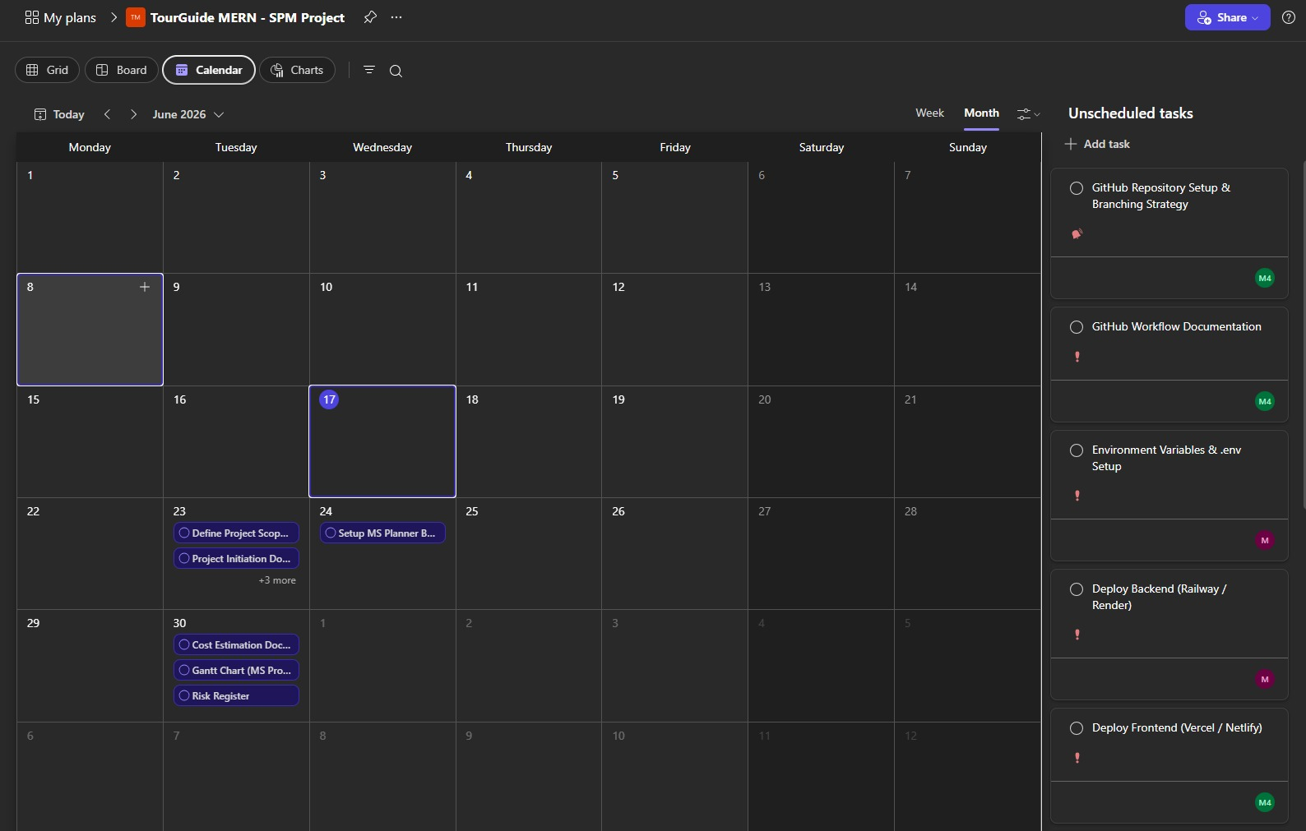
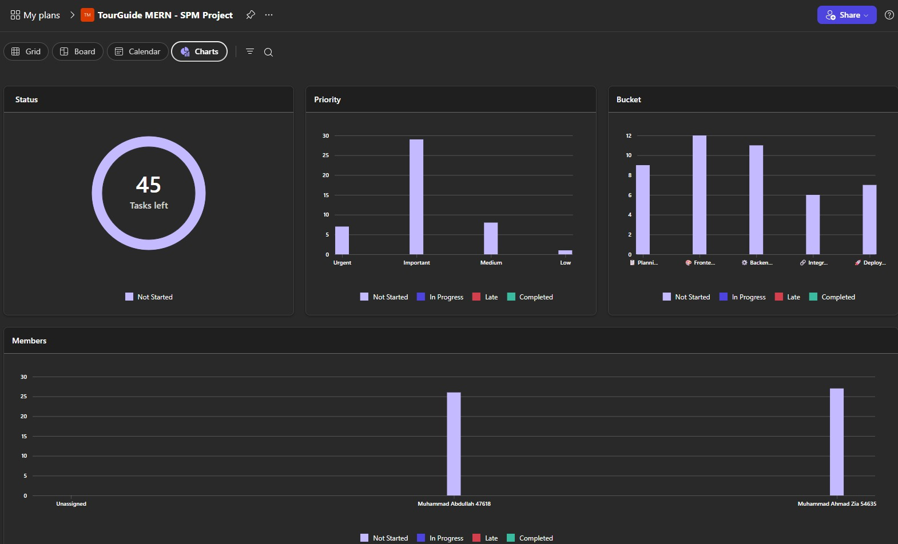

Lab 6:
1 .Taiga Project Management Tool:

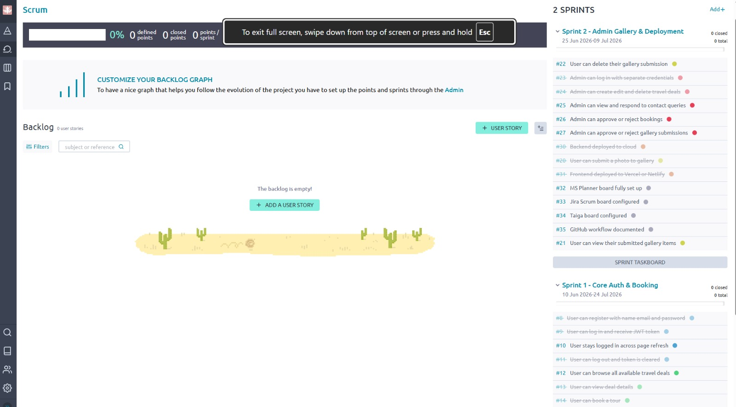
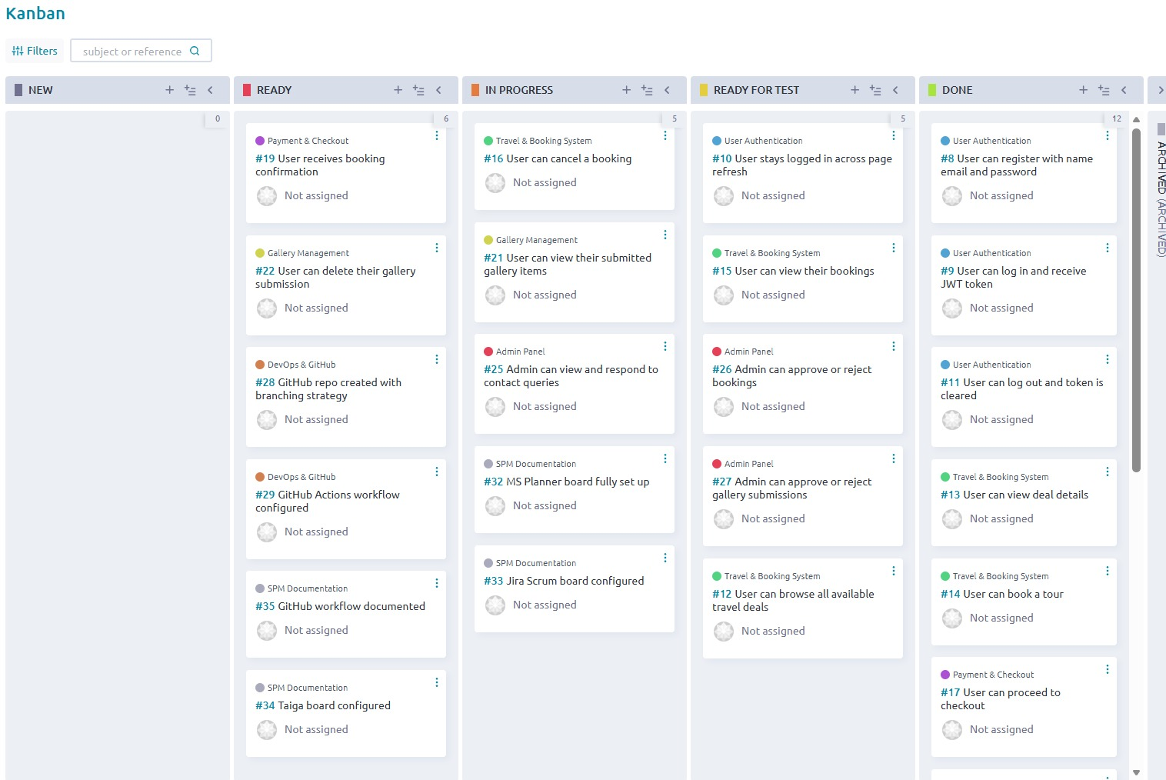
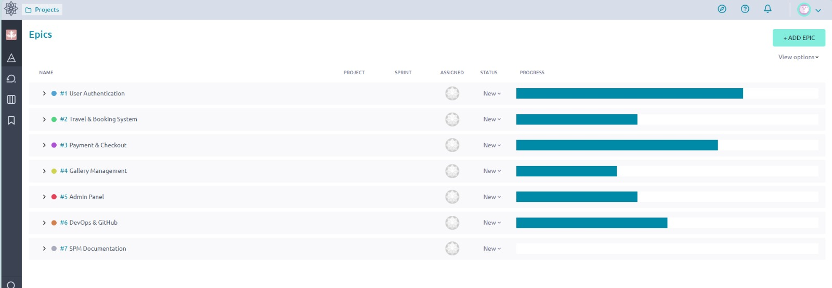

LAB 7

1. Work Breakdown Structure (WBS):

Introduction
The Tour Guide Application is a web-based platform that allows customers to browse and book tour packages online. The system provides features such as package booking, cart management, ratings, gallery uploads, and customer query submission. Administrators can manage tour packages, view customer queries, and monitor system activities.
The Work Breakdown Structure (WBS) decomposes the project into smaller manageable components for better planning, scheduling, estimation, and project control.

1.1. Tree Structure (Text-Based WBS)
◼ Tour Guide Application
▸ Authentication Module
• Welcome Screen
- Customer Button
- Admin Button
• Login System
- Login
- Validation
• Registration System
- Customer Registration
- Form Validation
• Logout System
▸ Customer Module
• Package Browsing
- View Packages
- Package Details
• Package Booking
- Select Package
- Confirm Booking
• Cart Management
- Add to Cart
- Update Cart
- Remove Package
- Total Price Calculation
▸ Feedback & Gallery Module
• Rating System
- Submit Rating
- View Ratings
• Gallery System
- Upload Image
- View Gallery
▸ Query Management Module
• Query Submission
- Submit Query
- Store Query Information
• Query Tracking
• Query Status
▸ Admin Module
• Admin Dashboard
- Activity Monitoring
• Package Management
- Add Package
- Update Package
- Delete Package
• Query Management
- View Queries
- Mark Query Resolved
▸ Database Management
• User Database
• Package Database
• Booking Database
• Query Database

1.2. Hierarchical Diagram Structure (Text Form)
Tour Guide Application
├── Authentication Module
│ ├── Welcome Screen
│ │ ├── Customer Button
│ │ └── Admin Button
│ ├── Login System
│ │ ├── Login
│ │ └── Validation
│ ├── Registration System
│ │ ├── Customer Registration
│ │ └── Form Validation
│ └── Logout System
│
├── Customer Module
│ ├── Package Browsing
│ │ ├── View Packages
│ │ └── Package Details
│ ├── Package Booking
│ │ ├── Select Package
│ │ └── Confirm Booking
│ └── Cart Management
│ ├── Add To Cart
│ ├── Update Cart
│ ├── Remove Package
│ └── Total Price Calculation
│
├── Feedback & Gallery Module
│ ├── Rating System
│ │ ├── Submit Rating
│ │ └── View Ratings
│ └── Gallery System
│ ├── Upload Image
│ └── View Gallery
│
├── Query Management Module
│ ├── Query Submission
│ │ ├── Submit Query
│ │ └── Store Query Information
│ ├── Query Tracking
│ └── Query Status
│
├── Admin Module
│ ├── Admin Dashboard
│ │ └── Activity Monitoring
│ ├── Package Management
│ │ ├── Add Package
│ │ ├── Update Package
│ │ └── Delete Package
│ └── Query Management
│ ├── View Queries
│ └── Mark Query Resolved
│
└── Database Management
├── User Database
├── Package Database
├── Booking Database
└── Query Database

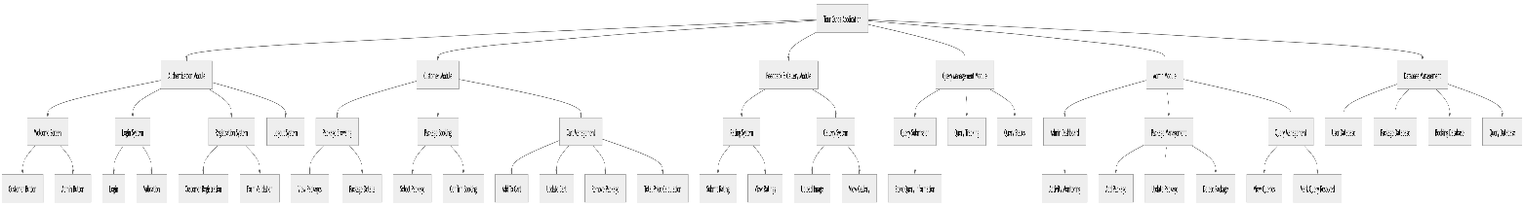

2. WBS Diagram (Level-Wise Structure)

LEVEL 0

Tour Guide Application

├── LEVEL 1: Authentication Module

│ ├── LEVEL 2: Welcome Screen

│ │ ├── LEVEL 3: Customer Button

│ │ └── LEVEL 3: Admin Button

│ │

│ ├── LEVEL 2: Login System

│ │ ├── LEVEL 3: Login

│ │ └── LEVEL 3: Validation

│ │

│ ├── LEVEL 2: Registration System

│ │ ├── LEVEL 3: Customer Registration

│ │ └── LEVEL 3: Form Validation

│ │

│ └── LEVEL 2: Logout System

├── LEVEL 1: Customer Module

│ ├── LEVEL 2: Package Browsing

│ │ ├── LEVEL 3: View Packages

│ │ └── LEVEL 3: Package Details

│ │

│ ├── LEVEL 2: Package Booking

│ │ ├── LEVEL 3: Select Package

│ │ └── LEVEL 3: Confirm Booking

│ │

│ └── LEVEL 2: Cart Management

│ ├── LEVEL 3: Add To Cart

│ ├── LEVEL 3: Update Cart

│ ├── LEVEL 3: Remove Package

│ └── LEVEL 3: Total Price

├── LEVEL 1: Feedback & Gallery Module

│ ├── LEVEL 2: Rating System

│ │ ├── LEVEL 3: Submit Rating

│ │ └── LEVEL 3: View Ratings

│ │

│ └── LEVEL 2: Gallery System

│ ├── LEVEL 3: Upload Image

│ └── LEVEL 3: View Gallery

├── LEVEL 1: Query Management Module

│ └── LEVEL 2: Customer Queries

│ ├── LEVEL 3: Submit Query

│ ├── LEVEL 3: Store Query

│ └── LEVEL 3: Track Query

├── LEVEL 1: Admin Module

│ ├── LEVEL 2: Admin Dashboard

│ │ └── LEVEL 3: Activity Monitoring

│ │

│ ├── LEVEL 2: Package Management

│ │ ├── LEVEL 3: Add Package

│ │ ├── LEVEL 3: Update Package

│ │ └── LEVEL 3: Delete Package

│ │

│ └── LEVEL 2: Query Management

│ ├── LEVEL 3: View Queries

│ └── LEVEL 3: Mark Resolved

└── LEVEL 1: Database Module

├── LEVEL 2: User Database

├── LEVEL 2: Package Database

├── LEVEL 2: Booking Database

└── LEVEL 2: Query Database

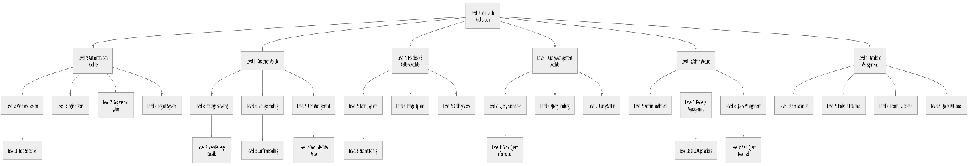

Lab 8: Network Diagram and Critical Path Method (CPM)

Step 1: Activity Table
Activity | Description | Duration (Days) | Predecessor
A | Requirement Gathering | 3 | -
B | System Design | 4 | A
C | Database Design | 3 | A
D | Frontend Development | 8 | B
E | Backend Development | 7 | C
F | System Integration | 3 | D, E
G | Testing | 4 | F
H | Deployment | 2 | G

Step 2: Network Diagram
A
/ \
B C
| |
D E
\ /
F
|
G
|
H

Flow Paths
Path 1:
A → B → D → F → G → H
Path 2:
A → C → E → F → G → H

Step 3: Forward Pass (EST & EFT)

Formula
EFT = EST + Duration
Activity | Duration | EST | EFT
A | 3 | 0 | 3
B | 4 | 3 | 7
C | 3 | 3 | 6
D | 8 | 7 | 15
E | 7 | 6 | 13
F | 3 | 15 | 18
G | 4 | 18 | 22
H | 2 | 22 | 24

Explanation
F starts only after both D and E are completed.
max(15,13) = 15
Therefore:
EST(F) = 15

Step 4: Backward Pass (LST & LFT)

Formula
LST = LFT − Duration
Activity | Duration | LST | LFT
H | 2 | 22 | 24
G | 4 | 18 | 22
F | 3 | 15 | 18
D | 8 | 7 | 15
E | 7 | 8 | 15
B | 4 | 3 | 7
C | 3 | 5 | 8
A | 3 | 0 | 3

Step 5: Slack Calculation

Formula
Slack = LST − EST
Activity | Duration | EST | EFT | LST | LFT | Slack
A | 3 | 0 | 3 | 0 | 3 | 0
B | 4 | 3 | 7 | 3 | 7 | 0
C | 3 | 3 | 6 | 5 | 8 | 2
D | 8 | 7 | 15 | 7 | 15 | 0
E | 7 | 6 | 13 | 8 | 15 | 2
F | 3 | 15 | 18 | 15 | 18 | 0
G | 4 | 18 | 22 | 18 | 22 | 0
H | 2 | 22 | 24 | 22 | 24 | 0

Step 6: Critical Path
Activities having Slack = 0
A → B → D → F → G → H

Critical Path Duration
A = 3
B = 4
D = 8
F = 3
G = 4
H = 2
Total Duration = 3 + 4 + 8 + 3 + 4 + 2 = 24 Days

Final Answer

Critical Path
A → B → D → F → G → H

Total Project Completion Time
24 Days

Lab 9:

1. Jira:

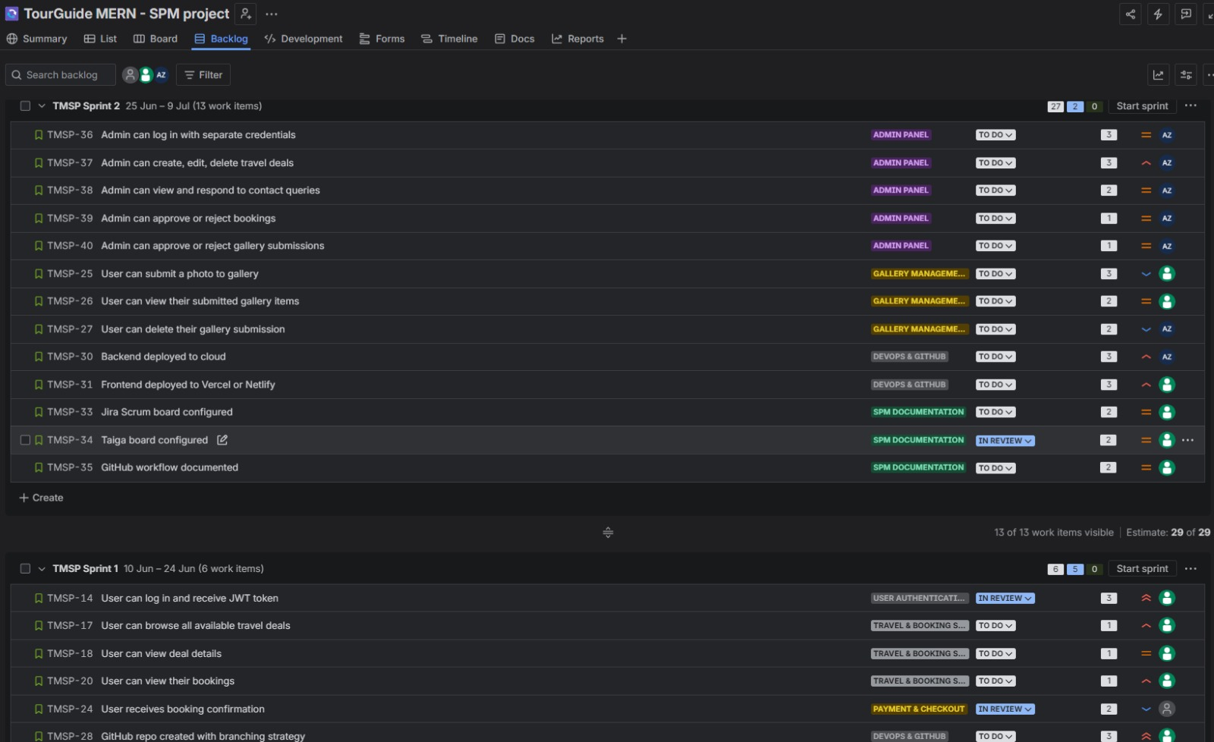

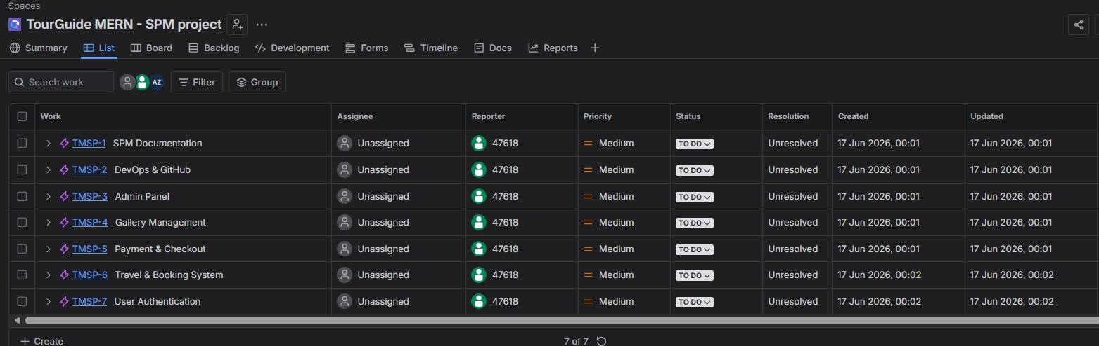

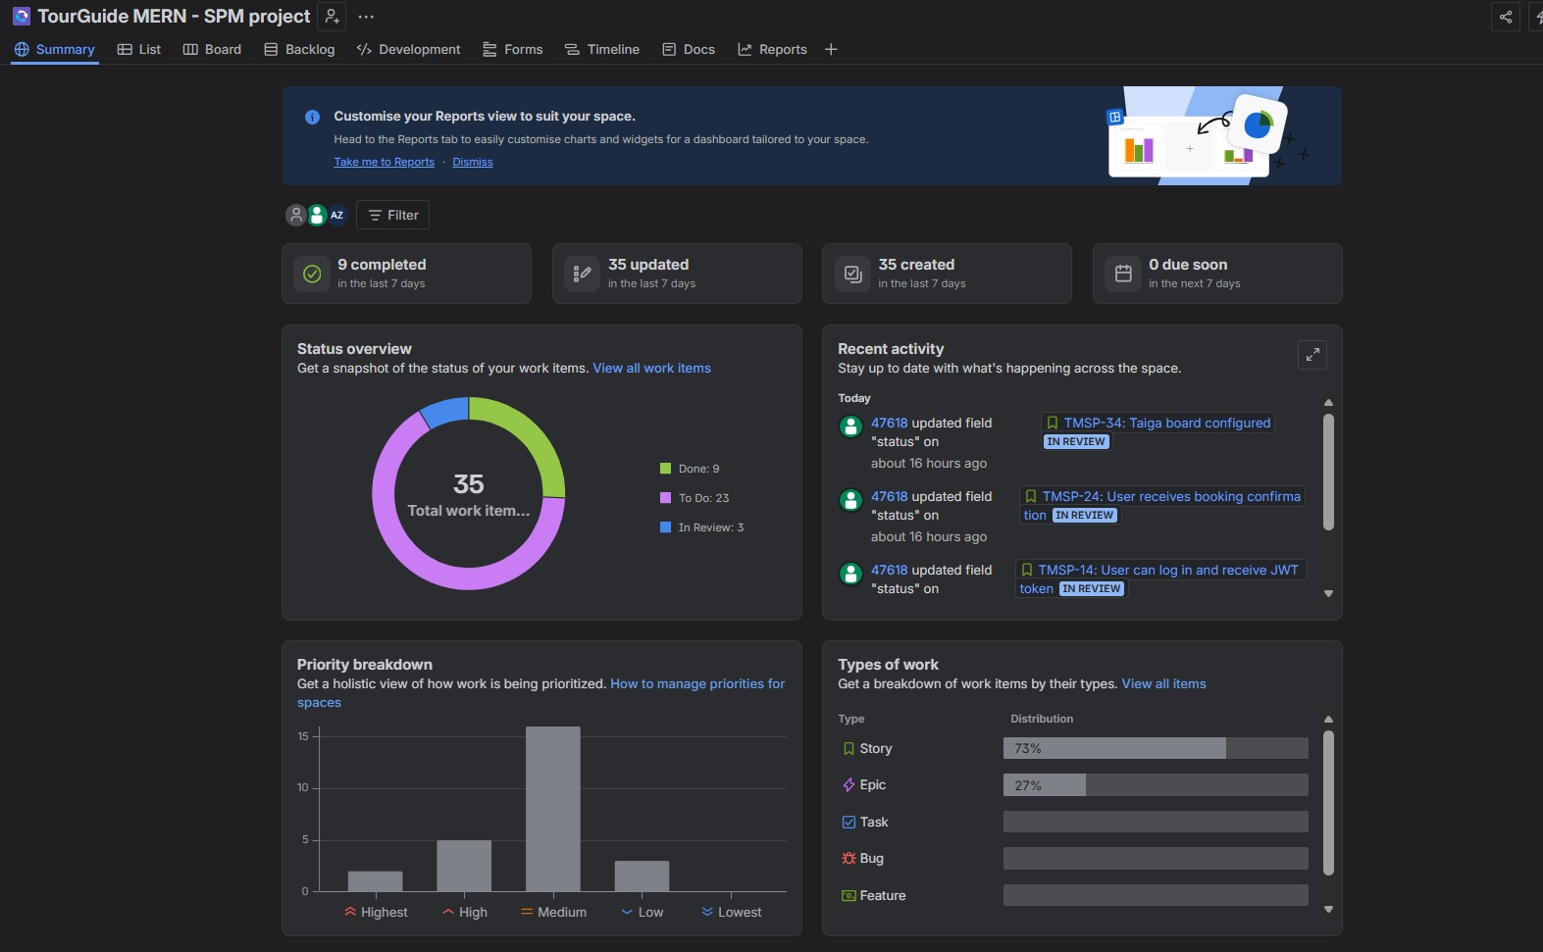

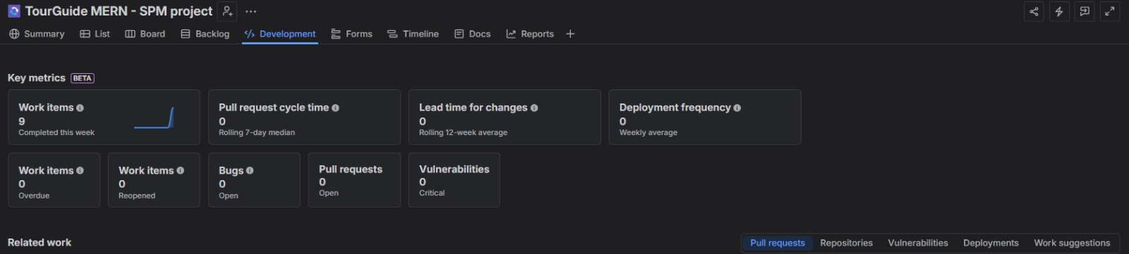

Lab 10:

1.Git

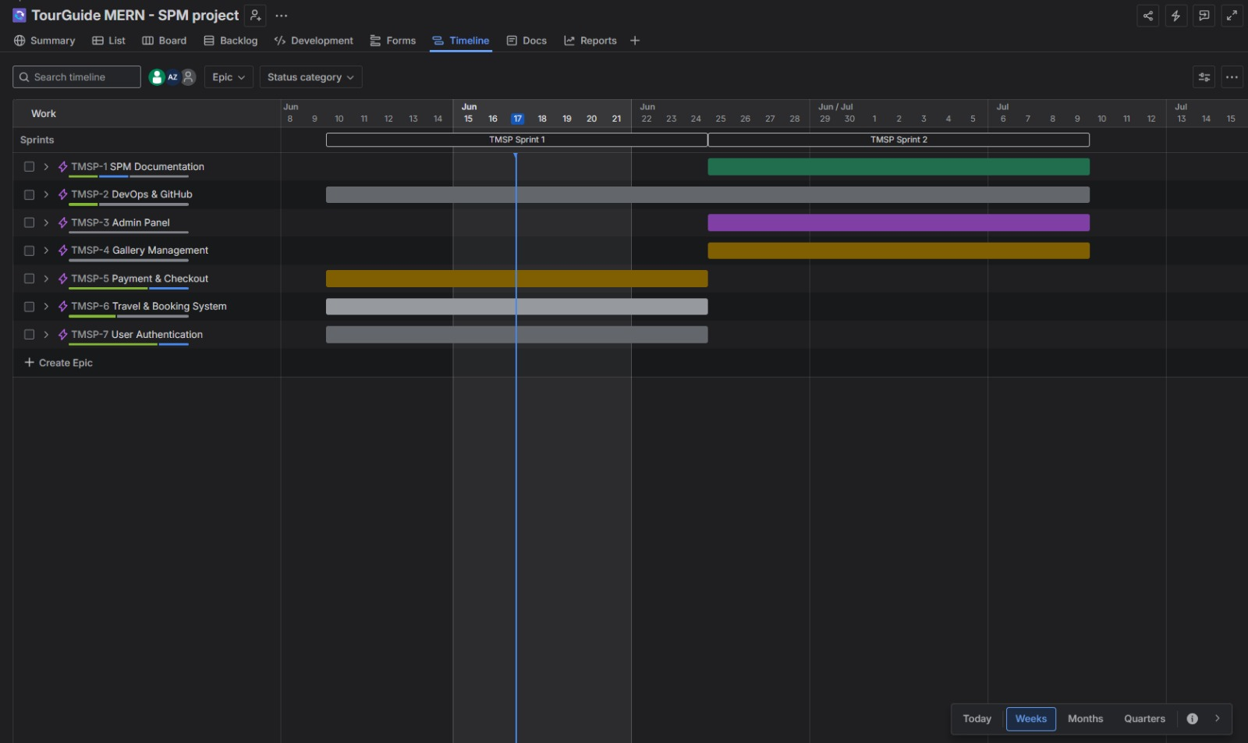

Lab 10:

Software Cost Estimation using LOC, Function Points, and COCOMO

Part A – LOC Estimation

Step 1: Estimated Modules
Module | Estimated LOC
Authentication Module (Login/Register) | 1000
Package Management | 2500
Booking & Cart Management | 2000
Rating & Gallery Module | 1200
Query Management | 1000
Admin Dashboard | 1800

Step 2: Calculate Total LOC
Formula:
Total LOC = Σ Module LOC
Calculation:
1000 + 2500 + 2000 + 1200 + 1000 + 1800
Total LOC = 9500

Step 3: Convert into KLOC
Formula:
KLOC = LOC / 1000
Calculation:
KLOC = 9500 / 1000
KLOC = 9.5

Result
Metric | Value
Total LOC | 9500
KLOC | 9.5

Part B – Function Point Analysis (FPA)

Step 1: Identify Components
Component | Count | Weight | Total
Inputs | 8 | 4 | 32
Outputs | 5 | 5 | 25
Queries | 4 | 4 | 16
Internal Files | 3 | 10 | 30
External Interfaces | 2 | 7 | 14

Explanation

Inputs
- Customer Registration
- Customer Login
- Admin Login
- Package Booking
- Add to Cart
- Submit Rating
- Upload Image
- Submit Query

Outputs
- Package List
- Booking Confirmation
- Cart Summary
- Query Status
- Reports

Queries
- Search Package
- View Booking
- View Gallery
- View Query Status

Internal Files
- User Database
- Package Database
- Booking Database

External Interfaces
- Payment Gateway
- MongoDB Atlas Cloud Services

Step 2: Calculate UFP
Formula:
UFP = Total Inputs + Outputs + Queries + Internal Files + External Interfaces
Calculation:
32 + 25 + 16 + 30 + 14
UFP = 117

Step 3: Apply VAF
Assume:
VAF = 1.05
Formula:
FP = UFP × VAF
Calculation:
FP = 117 × 1.05
FP = 122.85
FP ≈ 123

Result
Metric | Value
UFP | 117
Final FP | 123

Part C – COCOMO Estimation

Constants
Constant | Value
a | 2.4
b | 1.05

Effort Formula
Effort = a × (KLOC)^b
Substitute Values:
Effort = 2.4 × (9.5)^1.05
Effort ≈ 25.6 Person-Months

Estimated Effort
≈ 26 Person-Months

Final Estimation Summary
Metric | Estimated Value
LOC | 9500
KLOC | 9.5
Function Points | 123
Estimated Effort | 26 Person-Months

Cost Drivers Affecting Estimation
Cost Driver | Impact
Team Experience | Experienced developers reduce effort
Product Complexity | More features increase development cost
Reliability Requirements | Additional testing required
Tools & Technology | Modern frameworks improve productivity
Schedule Constraints | Tight deadlines increase effort
Database Complexity | More data management increases workload
Security Requirements | Login and user data protection increase cost

Inputs
- Registration
- Customer Login
- Admin Login
- Package Booking
- Add to Cart
- Submit Rating
- Upload Image
- Submit Query

Outputs
- Package List
- Booking Confirmation
- Cart Details
- Query Status
- Reports

Queries
- Search Package
- View Booking
- View Gallery
- View Query Status

Internal Files
- User Database
- Package Database
- Booking Database

External Interfaces
- Payment Gateway
- MongoDB Atlas

Task 3 Results

UFP = 117

FP = 123

LOC = 9500

KLOC = 9.5

Task 4 Result
Using Basic COCOMO:
Estimated Effort = 26 Person-Months

Lab 11:
1.Git

